Polygons

calculation of areas
and
overlap

Delphi
program
“Polygon-Overlap-Calculator”

algorithm description

D.E.Dirkse
Brederodestraat 28
1901HW Castricum
the Netherlands
email: david@davdata.nl

Introduction

This article describes the algorithm used by the program “Polygon-Overlap-Calculator”
which calculates the area of polygons as well as their overlap.
The polygons must be convex : their angles may not exceed 180 degrees.

In the picture below, we notice that only the blue polygon is convex, because angle 3 of the red one exceeds 180 degrees.

Below are two overlapping convex polygons.

Angles of the overlapping polygon are painted in black.
We notice different kinds of angles in this overlapping polygon :
edge crossings, blue angles (blue 3) and red angles (red 1).

The algorithm to calculate the overlap area takes the following actions :

- add intersection points of red and blue edges to a table
- inspect the red and blue angles to be
- an angle of the overlap and if so
- add point to the table.
- Search for path in the table from one point to another over connecting edges,
forming the overlap-polygon
- Cut overlap polygon into riangles.
- Calculate area of each triangle
- sum the triangle areas

Problems can be solved by a computer only if the problem is expressed in numbers.
Before starting we need some mathematics to accomplish this.
Below , find an introduction to vector geometry.

Coordinates and Lines

A line (or edge) in a coordinate system may be defined by it's starting and ending coordinates.
Below is line AB with A(1,2 ) as starting- and B(7,4) as ending point.

The path from A to B can be split into a horizontal motion of 7 – 1 = 6 (right) and
a vertical motion of 4 – 2 = 2 (up).

So line AB, without regard to it's position , may be defined as
AB = $\left(\begin{matrix}6 \\ 2\end{matrix}\right)$ this is the so called “vector notation”.

(please note : x up, y down)

Line BA = $\left(\begin{matrix}−6 \\ −2\end{matrix}\right)$ having point B as start and A as end.

Some rules in vector geometry.

The sum of two vectors

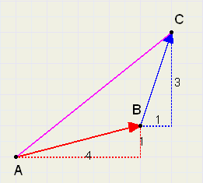
Vector AC is the sum of vectors AB and BC.
Addition means : draw head to tail.
A walk from A to B followed by a walk from B to C has the same result as a walk from
A to C directly.

Notation : AC = AB + BC = $\left(\begin{matrix}4 \\ 1\end{matrix}\right)+\left(\begin{matrix}1 \\ 3\end{matrix}\right)=\left(\begin{matrix}5 \\ 4\end{matrix}\right)$

general : $\left(\begin{matrix}a \\ b\end{matrix}\right)+\left(\begin{matrix}c \\ d\end{matrix}\right)=\left(\begin{matrix}a+c \\ b+d\end{matrix}\right)$

The difference of two vectors
Assume person A owns € 100 and B owns € 80. The difference (as seen by B) is

100 – 80 = 20.

The meaning is : B must earn € 20 to become as prosperous as A.

However, seen by A, the difference is 80 – 100 = -20

A must spend € 20 to be equal with B.

Difference means : destination point – starting point.

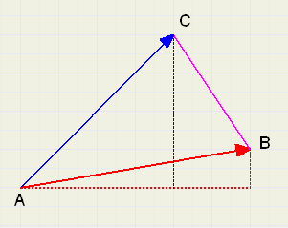

In figure above we see:

BC = AC – AB = $\left(\begin{matrix}4 \\ 2\end{matrix}\right)−\left(\begin{matrix}6 \\ 1\end{matrix}\right)=\left(\begin{matrix}−2 \\ 3\end{matrix}\right)$ BC is the road from vector AB to vector AC :.
(2 left, 3 up)

general : $\left(\begin{matrix}a \\ b\end{matrix}\right)−\left(\begin{matrix}c \\ d\end{matrix}\right)=\left(\begin{matrix}a−c \\ b−d\end{matrix}\right)$

Vector multiplication by a scalar

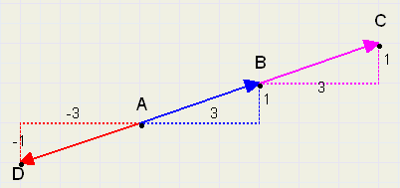
We see : AC = 2*AB and also : AD = - 1*AB or shorter : AD = - AB

AC = $2\left(\begin{matrix}3 \\ 1\end{matrix}\right)=\left(\begin{matrix}6 \\ 2\end{matrix}\right)$ and AD = $−\left(\begin{matrix}3 \\ 1\end{matrix}\right)=\left(\begin{matrix}−3 \\ −1\end{matrix}\right)$

general : $a\left(\begin{matrix}b \\ c\end{matrix}\right)=\left(\begin{matrix}ab \\ ac\end{matrix}\right)$ {a is a scalar, so any single number}

The vector equation of a line
Figure below shows vector AB on line l..
Vector OB = OA + AB. {O is the point (0,0) of the coordinate system}
By multiplying AB ( to make it longer or shorter) and adding vector OA, we may reach any point on the line l.

For an arbitrary point P om l : OP = OA + k.AB, where k is any number.

So, the equation of the line below is : $\left(\begin{matrix}x \\ y\end{matrix}\right)$ = $\left(\begin{matrix}2 \\ 1\end{matrix}\right)+k.\left(\begin{matrix}5 \\ 2\end{matrix}\right)$

Each value of k results in a point on line l.

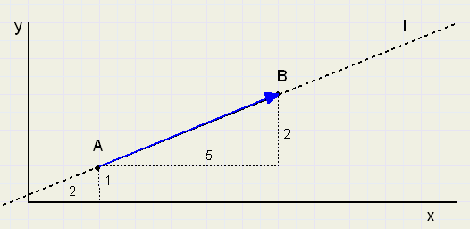
The intersection of two lines
In the following figure we notice lines having the equation:

blue: $\left(\begin{matrix}x \\ y\end{matrix}\right)=\left(\begin{matrix}1 \\ 3\end{matrix}\right)+k.\left(\begin{matrix}4 \\ 1\end{matrix}\right)$ red : $\left(\begin{matrix}x \\ y\end{matrix}\right)=\left(\begin{matrix}2 \\ 1\end{matrix}\right)+m.\left(\begin{matrix}3 \\ 2\end{matrix}\right)$

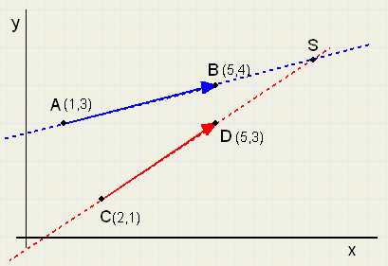
to find the coordinates of intersection S, we have to solve k and m in

$\left(\begin{matrix}1 \\ 3\end{matrix}\right)+k.\left(\begin{matrix}4 \\ 1\end{matrix}\right)=\left(\begin{matrix}2 \\ 1\end{matrix}\right)+m.\left(\begin{matrix}3 \\ 2\end{matrix}\right)$

By remembering the rules for addition and multiplication, we may write:

1 + 4k = 2 + 3m or 4k – 3m = 1
3 + k = 1 + 2m k – 2m = -2 {* -4 to eliminate k }

4k – 3m = 1
-4k + 8m = 8 now add:

5m = 9
m = 1,8

back to the original equations:

4k – 3m = 1 {* -2} -8k + 6m = -2
k – 2m = -2 {* 3} 3k – 6m = -6 and add

-5k = -8
k = 1,6

Note, that both k and m are positive and bigger than 1 .
Reason is, that AS is a positive extension of AB and CS is a positive extension of CD.

If S had been on AB and CD , then 0 < k < 1 and also 0 < m < 1.
Negative values of k and m indicate, that S is positioned before (the head) of the vector so ,
AS would be a negative extension of AB (reversed direction).
The values of k and m supply important information about the relatieve position of the edges AB en CD.

The coordinates of intersection S can now be calculated:

x = 1 + 4.k = 1 + 4 . 1,6 = 7,4
y = 3 + k = 3 + 1,6 = 4,6

To conclude this introduction to vector geometry, the general case of intersecting lines
is presented.

In the figure ahead we notice points A(x1,y1) , B(x2,y2) , C(x3,y3) en D(x4,y4)

Vector AB = $\left(\begin{matrix}x2−x1 \\ y2−y1\end{matrix}\right)$ CD = $\left(\begin{matrix}x4−x3 \\ y4−y3\end{matrix}\right)$

we define : x2-x1 = a x3-x2 = b
y2-y1 = c y4-y3 = d

resulting in equations

{AB} : $\left(\begin{matrix}x \\ y\end{matrix}\right)=\left(\begin{matrix}x1 \\ y1\end{matrix}\right)+fa.\left(\begin{matrix}a \\ c\end{matrix}\right)$

{CD} : $\left(\begin{matrix}x \\ y\end{matrix}\right)=\left(\begin{matrix}x3 \\ y3\end{matrix}\right)+fb.\left(\begin{matrix}b \\ d\end{matrix}\right)$

fa and fb are numbers (like k and m before) to multiply the vectors.
We use the multiplication operator . (point) in this case.
Following system of equations has to be solved:

x1 + fa.a = x3 + fb.b or fa.a - fb.b = x3 - x1
y1 + fa.c = y3 + fb.d fa.c - fb.d = y3 - y1

define : x3 – x1 = e
y3 - y1 = f resulting in :
a.fa – b.fb = e
c.fa – d.fb = f

remark : notation a,b,...fa and fb is used because the program source code has the same notation.

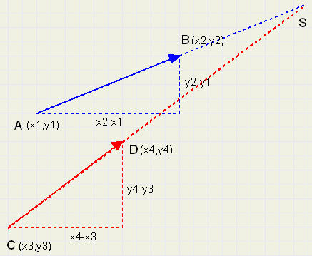

To solve this system of equations, multiply row 1 by c and row 2 by a, then subtract row 2 from row 1.

a.c.fa – b.c.fb = c.e
a.c.fa – a.d.fb = a.f
-
a.d.fb – b.c.fb = c.e – a.f

so
fb.(a.d – b.c) = c.e.- a.f

$$fb=\frac{\left(c.e−a.f\right)}{\left(a.d−b.c\right)}$$

similar: (row 1 * d, row 2 * b) :

$$fa=\frac{\left(d.e−b.f\right)}{\left(a.d−b.c\right)}$$

a.d – b.c may not be zero, as division by zero is not possible.
a.d = b.c means, that the lines are parallel, there is no intersection in this case.

So far, enough mathematics and we return to the original polygon problem.

Apoints, Bpoints and Edge lists.
We call the polygons A (painted in blue) and B (painted in red).
A polygon is defined by all the coordinates of it's angles, so by a list of these coordinates.
If A is a quadrilateral , the list (called Apoints) could be :

Apoints: angles : 4 {the number of angles}
coordinates 1. (5, 5) {angle point 1...........enz}
2. (25, 0)
3. (20,20)
4. (10,15)
If B is a triangle :
Bpoints: angles : 3
coordinates 1. (5,0)
2. (20,0)
3. (10,20)
Apoints and Bpoints lists are the start of the process.
From lists Apoints and Bpoints, two new lists are made, that describe the edges.
These lists are called Aedges (for A) and Bedges (for B).
Aedges: edges : 4
coordinates : 1. (5, 5) , (25, 0) {begin- and end coordinates}
2. (25, 0) , (20,20)
3. (20,20) , (10,20)
4. (10,20) , ( 5 ,5)
Bedges: edges : 3
coordinaten : 1. (5, 0) , (20, 0)
2. (25, 0) , (10,20)
3. (10,20) , ( 5, 0)

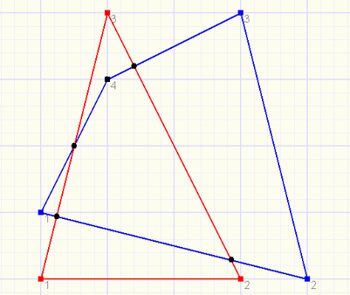
Relative position of edges
We have to search for points that are angles of the overlapping polygon.
Following cases may be distinguished:

1. an intersection (of red and blue) always is a point of the overlap polygon
so : ( 0 < fa < 1 ) and ( 0 < fb < 1)

now look at blue point 4 in the previous figure.
Blue side 3 (from point 3 to 4) intersects red edge 2 and it's extension intersects red edge 3.
These combinations of fa values make blue point 4 a point of the overlap polygon.

2 .if 0 < fa < 1 for one intersection and fa > 1 for another , then the blue
destination point is a point of the overlap polygon.

similar:

3. if 0 < fa < 1 (for one intersection) and fa < 0 (other intersection) then the blue
starting point is a point of the overlap polygon.

Also :

4. if fa < 0 (one interection with red edge) and fa > 1 (other with red edge)
then both blue points belong to the overlap polygon.

In a similar way, red points can be selected that are part of the overlap polygon.
Figure below illustrates the way blue points are examined.

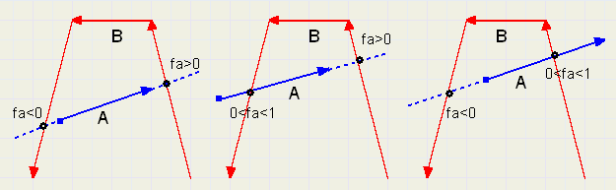
Please note : in each case above 0 < fb < 1. We are only interested in intersections with
red edges, not extensions of red vectors (edges).

The 'Intersection' list. (ISlist)

Every blue edge is examined for it's intersection with every red edge.
Eaxch comparison results in a fa and a fb value.
The ISlist , in this case, has 4 columns (one for every blue edge) and 3 rows (one for every red edge). So, the list has 12 fields and a field holds :

fa : a real number { indicaes the position of the intersection: before,on,after}
fb : a real number { but for edge B}
valid : “true”or “false” , a logical variable. “False” if edges are parallel and no
intersection exists.

The ISlist below represents our example.

 | A edge 1 | A edge 2 | A edge 3 | A edge 4
B edge 1 | fa= 1  fb= 1.33  valid=true | fa= 0  fb= 1.33  valid=true | fa= 4  fb= -1.67  valid=true | fa= 1.5  fb= -0.17  valid=true
B edge 2 | fa= 0.71  fb= 0.07  valid=true | fa= -1  fb= -1  valid=true | fa= 0.8  fb= 0.8  valid=true | fa=-0.25  fb= 0.89  valid=true
B edge 3 | fa= 0.06  fb= 0.76  valid=true | fa= 2  fb= -1  valid=true | fa= 1.14  fb= 0.29  valid=true | fa= 0.5  fb= 0.5  valid=true

By analysing this table we find the points of the overlapping polygon.
Note : fa = 0 if intersection is starting point of vector (edge).
fa = 1 if intersection is ending point of vector.

The Innerpoint list (IPlist)
This list contains all points found to be angles of the overlap polygon.
But more : the same point may appear several times in this list.
A field of this list contains

- (x,y) the coordinates of the intersection or point
- ia : edge number in Aedge list
- ib : edge number in Bedge list

Variable top indicates the number of rows (entries) in the list.

In this case : ISlist - top = 6

 | (x , y) | ia | ib
1 | (19.29 , 1.42) | 1 | 2
2 | (6.18 , 4.71) | 1 | 3
3 | (12 , 16) | 3 | 2
4 | (7.5 , 10) | 4 | 3
5 | (10 , 15) | 3 | 0
6 | (10 , 15) | 4 | 0

The coordinates were calculated from edge information and fa, fb using the procedure described before.
Point (10 , 15) appears two times in the list. First as point on blue side 3 and second as point on blue side 4.
If intersections coincide with angles, the same point may appear maximally 6 times in the list.

The TrackList
This list contains a row per point of the overlapping polygon.
A field contains:

- (x,y) : the coordinates of the point
- ematch : a bitvector (type 32 bit Integer) , later explained
- visited : a boolean variable (true of false), later explained

The Tracklist is constructed using the IPlist.
Therefore, the IPlist is scanned row by row (point by point).
If the point (x,y) is not yet present in the Tracklist, it is added to it.
Because ia = 1 bit 1 of Ematch is set.
Because ib = 2 bit 2 + 12 = 14 of Ematch is set. {B values : add bias of 12 to bit position}
For ia = 0 or ib = 0, Ematch remains unchanged.

Ematch contains, in bitwise coded form, all edges where the point (x,y) belongs to.

In this case : {Ematch displayed in binary)

 | coordinates | Ematch (bits)
1 | (19.29 , 1.42) | 0100 0000 0000 0010
2 | (6.18 , 4.71) | 1000 0000 0000 0010
3 | (12 , 16) | 0100 0000 0000 1000
4 | (7.5 , 10) | 1000 0000 0001 0000
5 | (10 , 15) | 0000 0000 0001 1000

The PolyList
This list contains the final result of our efforts : all punts, neatly sequenced, that are angles
of the overlapping polygon.
The Polylist is constructed from the Tracklist.
As a start, point 1 of the Tracklist is added to the Polylist. Ematch value being remembered.
In row 1 of the Tracklist , variabele visited is set to “true” gemaakt. This inhibits further use
of this point.
Now, the remembered value of Ematch is used to look further into the Tracklist to find an Ematch value with any corresponding bit set. (which means : find point on same edge, or otherwise formulated : find a connecting edge to the next point)
We find a hit at row 2 , where bit 1 is set (0000 0000 0000 0010) .
The point on row 2 (of Tracklist) is now added to the Polylist and the “visited” variable of row 2 is set true, not to use this point ever again.
With the Ematch value of row 2 we find Tracklist row 4, where bit 15 is set.
(1000 0000 0000 0000)
From row 4, we find row 5 (0000 0000 0001 0000) and finally from row 5 we end at row 3 where the bitvector is (0000 0000 0000 1000) .

The resulting Polylist is :

1 | (19.29 , 1.42)
2 | (6.18 , 4.71)
3 | (7.5 , 10)
4 | (10 , 15)
5 | (12 , 16)

Calculating the area of a polygon.
The polygon is split into triangles, by adding lines to any angle from point 1.

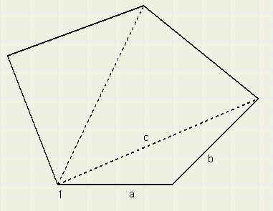
Then, the length of each side of a triangle is calcualated:
If an edge starts at (x1,y1) and ends at (x2,y2)

the length is $\sqrt{{\left(x2−x1\right)}^{2}+{\left(y2−y1\right)}^{2}}$

and using a,b,c as the edges of the triangle, it's area is

$\sqrt{s\left(s−a\right)\left(s−b\right)\left(s−c\right)}$ where s = $\frac{\left(a+b+c\right)}{2}$ half the perimeter.

Remains , to sum all areas to find the final overlap area.

.

Test for convex polygon

The algorithm described before , only is valid in case of convex polygons.
The next procedure tests this property.

Say, we want to test Apoints.
Using Apoints only, lists Aedges and Bedges are made, so both edge lists are identical.
The ISlist is now built, using the standard procedure.

The test now continues by counting the number of intersections of each edge.
Per edge, this count must be 2 (the adjacent edges) , extended edges may not intersect
other edges.

See the example below:

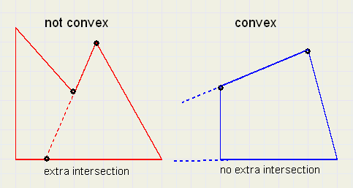

This concludes the description of the Polygon-Overlap algorithm.

